

**MUHAMMAD ABID UR REHMAN**

**OFFENSIVE INTERN**

**Team Lambda**

TASK – 1 (RECON TOOL)

**ATOMIC SCANNER**

Hello All , This is Project Based Educational Tool only Developed for Educational Purpose.

With all things like Domain Enumeration , port Scanning whether its WHOIS Lookup or its Banner Grabbing; Using a different Tool for Each time is quite irritating.

For the solution We introduce you to :

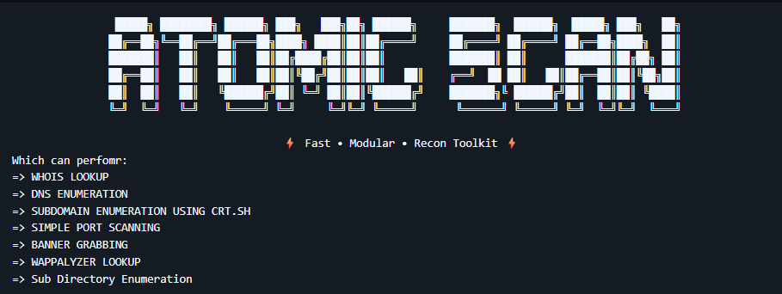

The Usage Guide is as Follows:

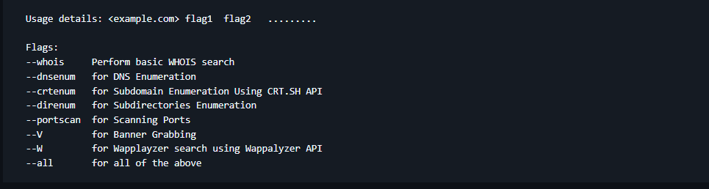

It just take Domain as input and perform all the necessary operation as per provided by the User.

Github link is: [Atomic Scanner](https://github.com/M-Abid34/Atomic-Scanner)

It is easily installable using the following command:

* wget https://codeload.github.com/M-Abid34/Atomic-Scanner/zip/refs/heads/main
* git clone https://github.com/M-Abid34/Atomic-Scanner.git

For making it operational You need to install Python Wappalyzer Package through the following command:

* pip install python-Wappalyzer

It is a basic level and can be upgraded to advance level as per requirement and it is fully developed from scratch and works perfectly on real world targets.

Example Usage:

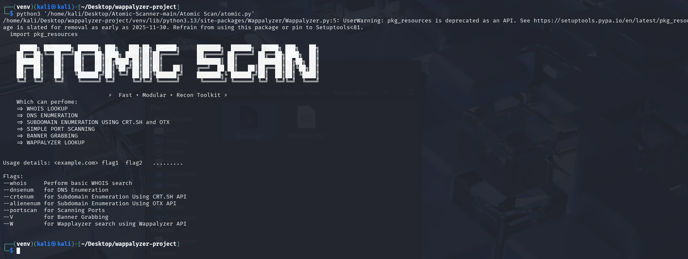

We can perform our scan on website like [scanme.nmap.org](http://scanme.nmap.org/)

It might block few API like wapplyzer and dns enumeration but we can see the rest result as these website are designed to block any unwanted scan especially Active scans:

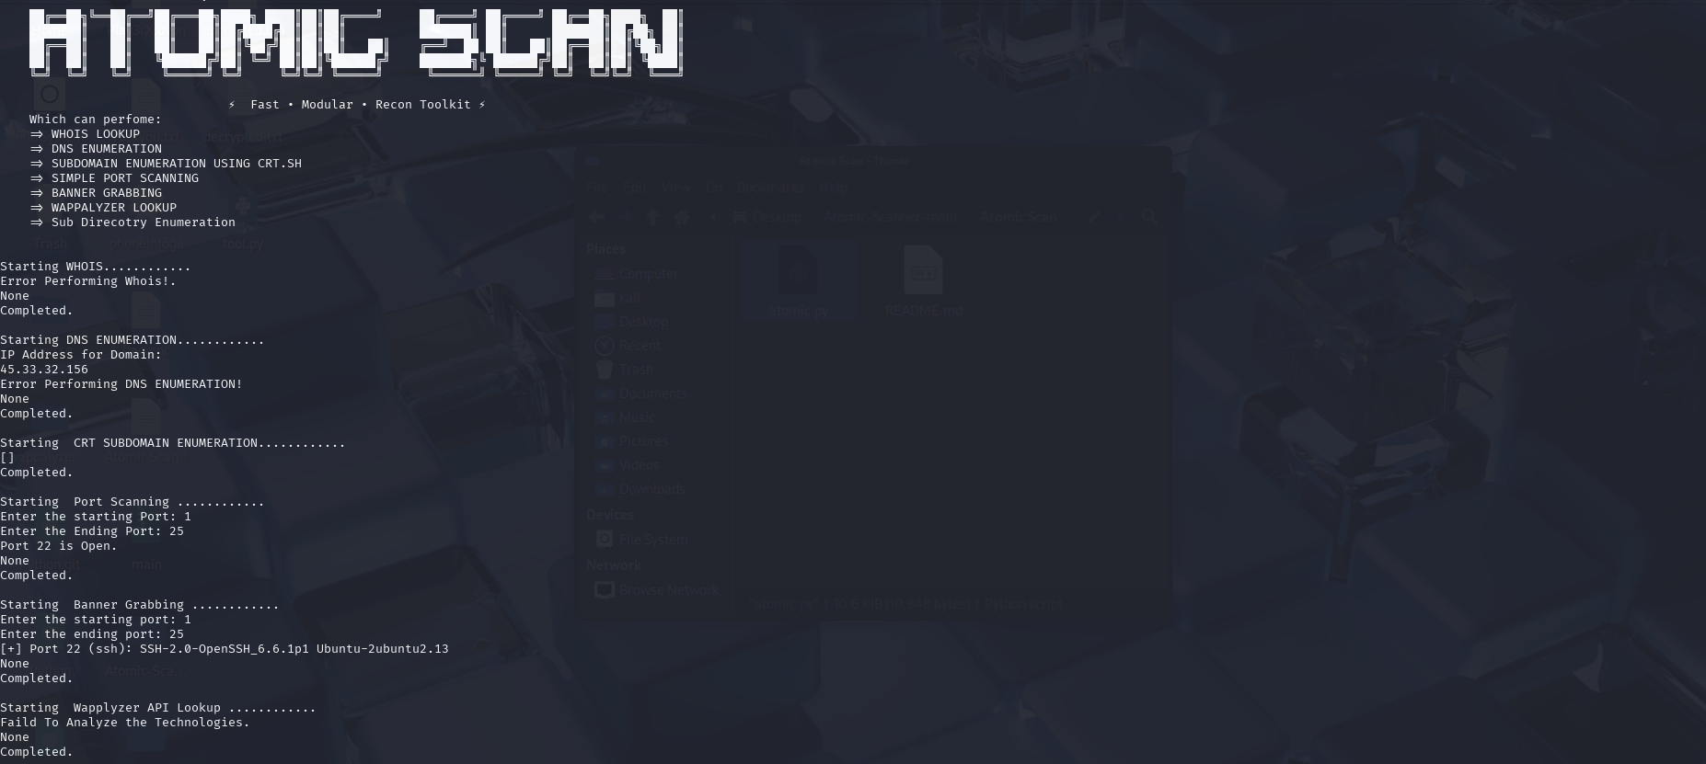

As per Subdomain and Dns enum was blocked also the Wappalyzer API was also blocked and since I don’t got any legall target atm so we cannot perform any active scan.

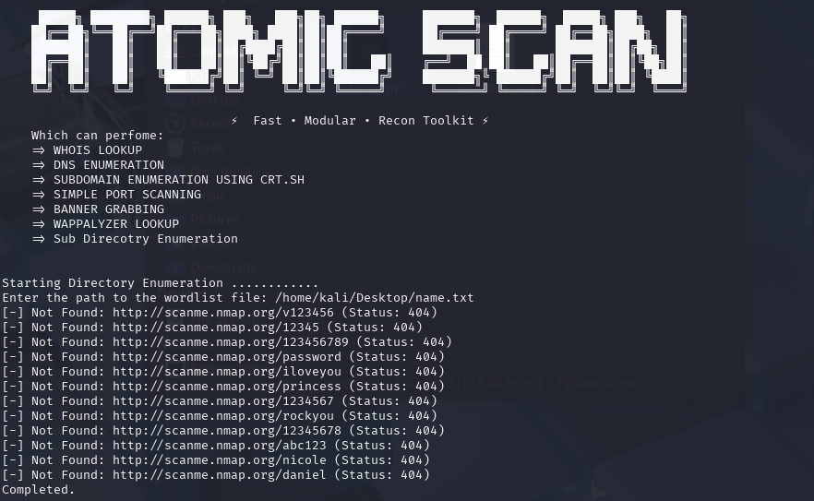

Also the Sub Directory Enumeration.

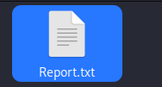

All results as being saved in Report.txt but make sure to make a copy of this file and delete it before performing a new Scan.

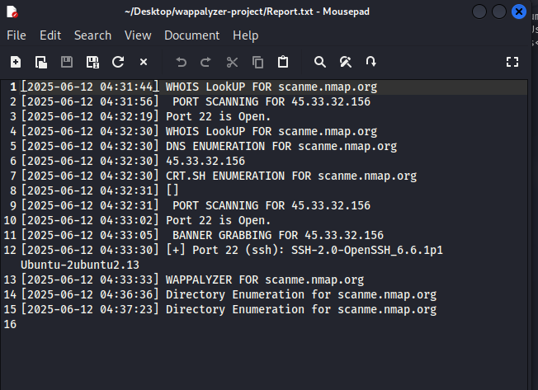

Since much was blocked so it contains little information.

CRT subdomain enumeration on google.com

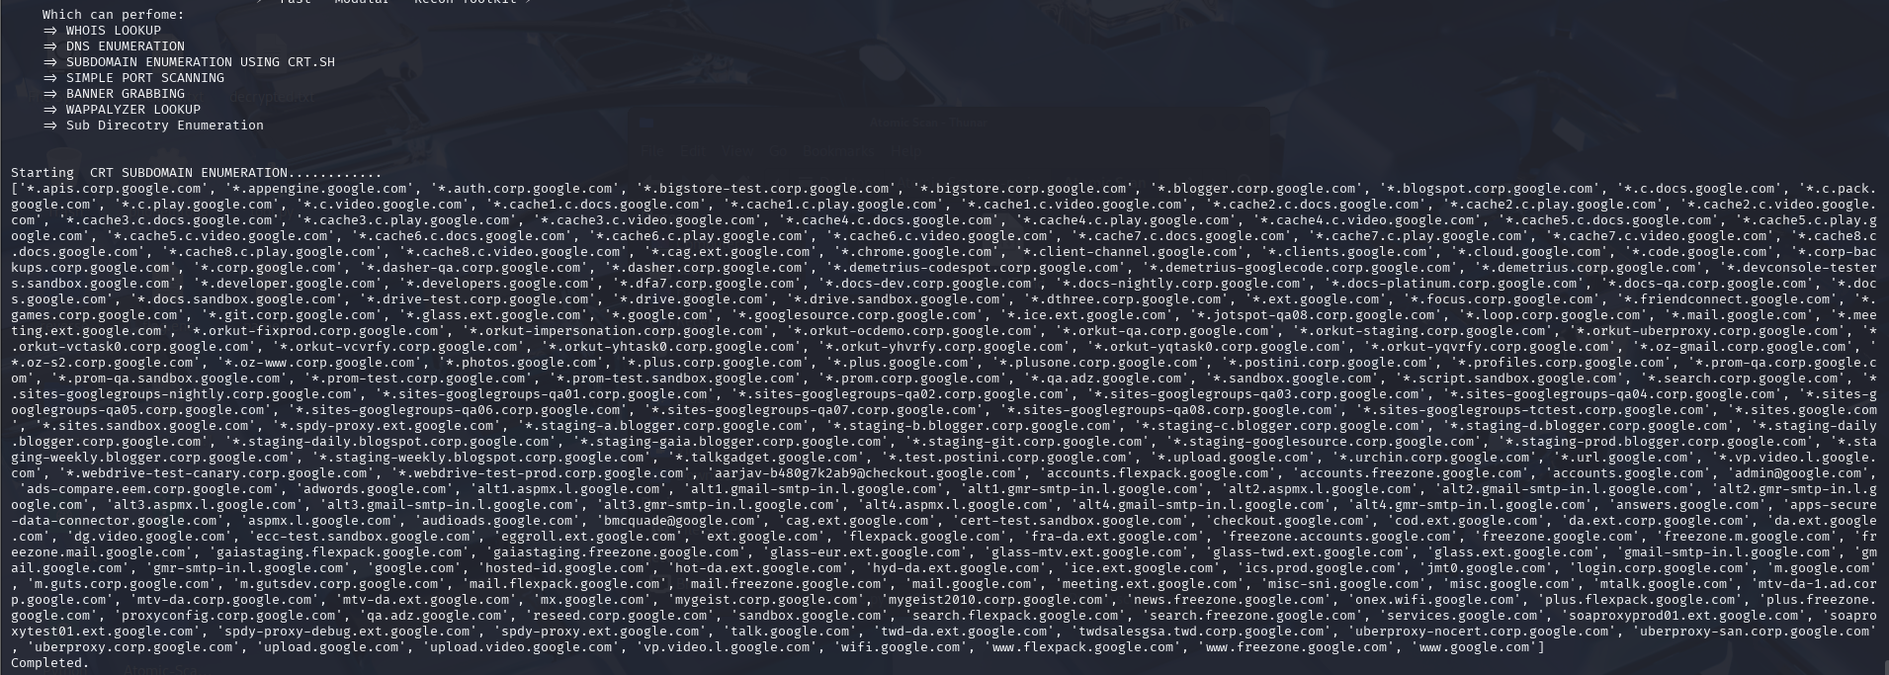

DNS ENUMERATION FOR GOOGLE.COM:

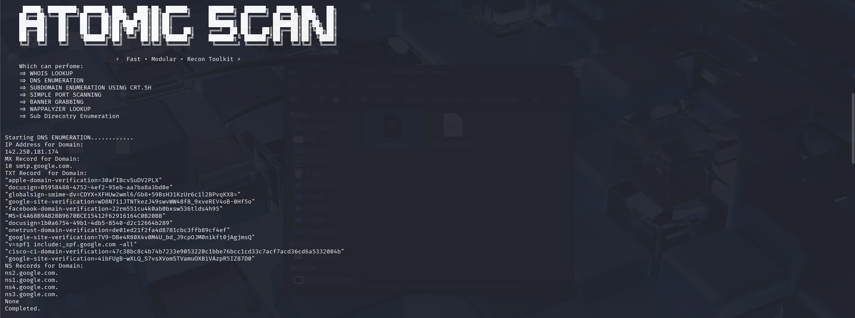

The result are save as below in Report.txt:

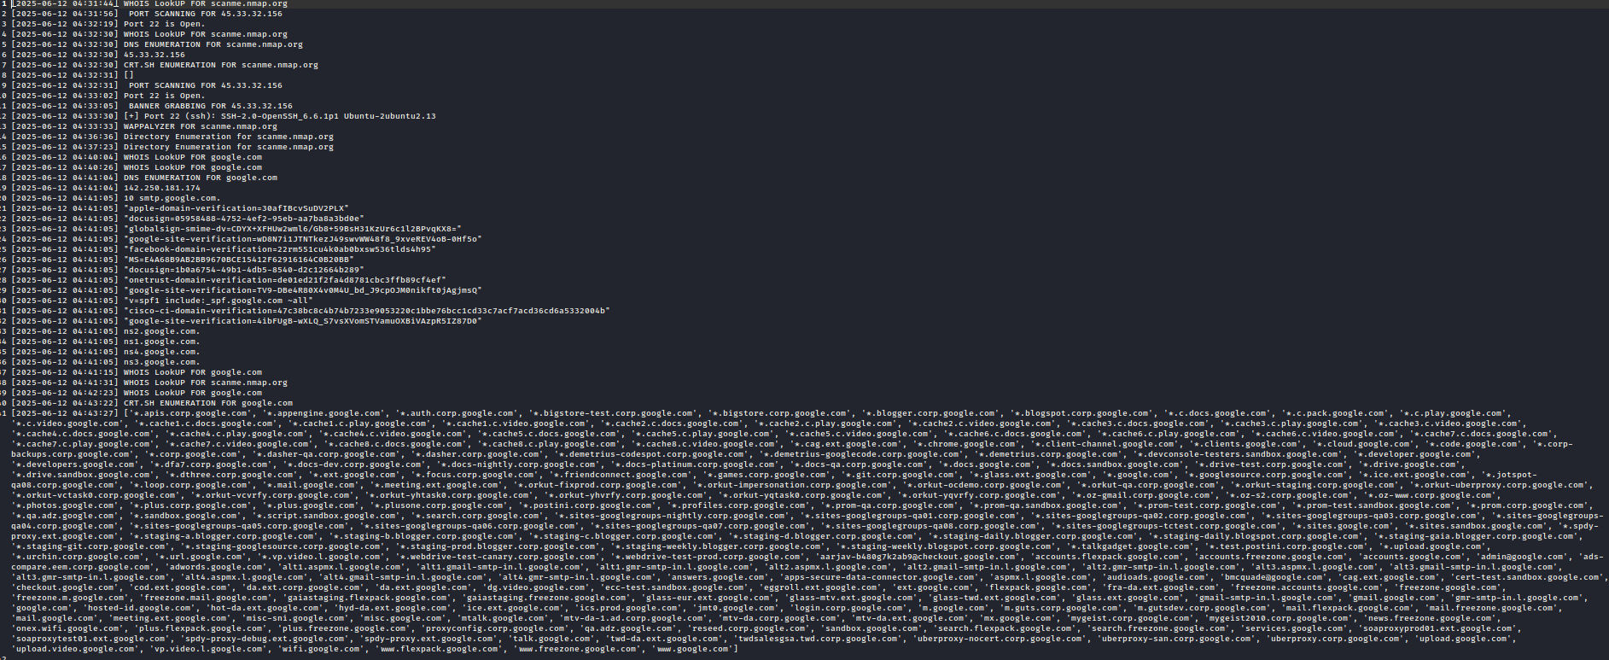

As I cannot directly perform active Scanning so that is all the rest cannot be tested here.

THANK YOU HOPE YOU FIND IT USEFUL.

It is just beginning we will try to improve more and more by Time.